**UNIFICATION OF LOGS**

The above proposed work is done using the technology which is known as Python/Django.

the codes are written in python and the backend use is sqlite3 which is inbuilt database in Django.

The project consists of different UIs created using Html and CSS

**Working:**

Firstly the investigator fill all the details of the forms then it will redirect to the upload file .

The file (database logs) entered by the investigator will convert into the csvs and the data s stored in the database on the basis of ip address and timestamps and some other details.

**Database:**

The database can be accessed by creating super user.

Some snapshots of codes:

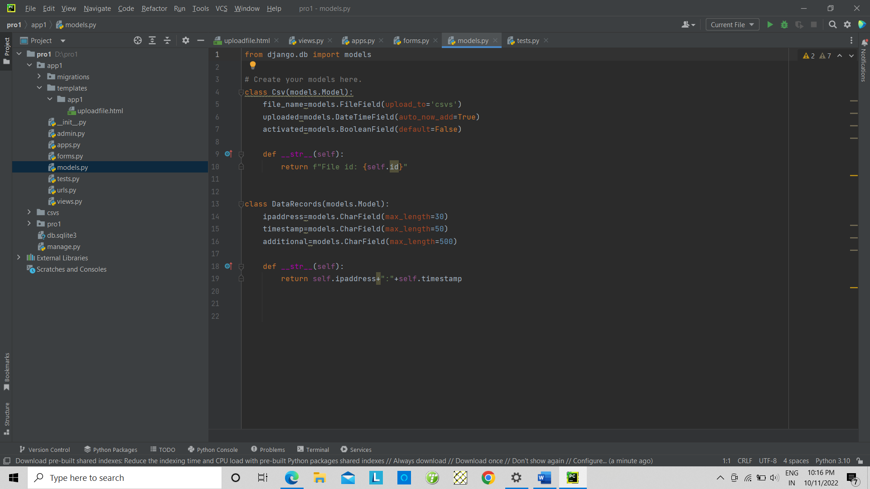

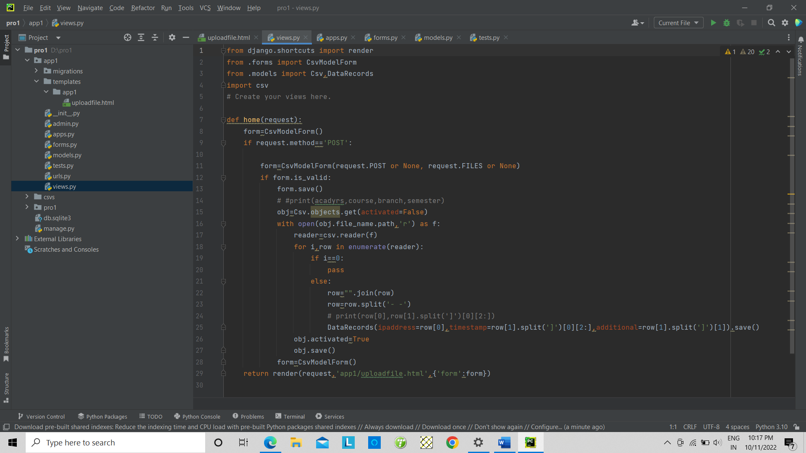

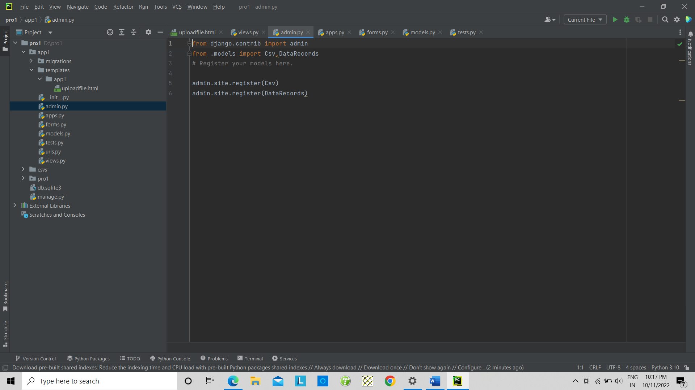

**Commands use to run the program**

Python manage.py runserver

Python manage.py makemigrations

Python manage.py migrate

Python manage.py createsuperuser